**HTML & CSS Help Sheet**

|  |  |  |  |
| --- | --- | --- | --- |
| Name: |  | Class: |  |

This guide is to help you create your website for your HTML and CSS Assessment. You have 2 lessons to complete this assessment.

Key Considerations for all Web Designers:

* **Target Audience**: - Who is your website aimed at?
* **Consistency**: – Colour schemes, fonts, layout, the same on every page
* **Content:** - What information are you doing to include?
* **Simplicity**: - Do not over clutter each page or include un-necessary information
* **Elegance:** - What designs will attractive your target audience?

|  |  |
| --- | --- |
| Category | Describe/Explain/Justify your design decisions |
| Website Name | Skateboarding |
| Target Audience | To help people improve on their tricks |
| Website Description |  |
| Colour Scheme | Background:  Fonts:  Hyperlinks:  Logo: |
| Images required |  |

**Task 1 - Collecting**

Collect all your resources and save them in your HTML Website folder. Resources include images, text, graphics for buttons and a logo. You can use other software packages like Adobe Photoshop to create your own graphics. However it can take time for you to create your own graphics and might leave you with little time to complete the rest of the assessment.

**Task 2 - Copying**

Copy the templates from the Shared Area into your own HTML Website folder.



**HTML**

**Website**

Open **Notepad++** and then open the **CSS file** and the **HTML document**

**Task 3 – Creating and Editing**

Edit the HTML and CSS files to create your homepage.

**Add content to the HTML file and change the presentation properties of the CSS.**

**Save the files** and refresh the web browser to see the effect your changes have on the HTML file.

To insert images you need to add this code to the correct section of the HTML file:

*<img src=“London.jpg” width= 200px>*

Change London to the name of your image. Check the file type (jpg, gif, png) and set the width to your choice.

**Task 4 – Hyperlinking**

To insert hyperlinks add this code to the HTML file:

***<a href=“AboutUs.html">About Us</a>***

***<a href=”***[***http://www.bbc.co.uk***](http://www.bbc.co.uk)***>Link to BBC</a>***

Change “AboutUs” to the name of your hyperlink.

Set up all your hyperlinks before you create any other web pages.

**Task 5 – Saving the Home Page**

Save your Home Page. Click **File 🡪 Save As** and call it **“index.html”**

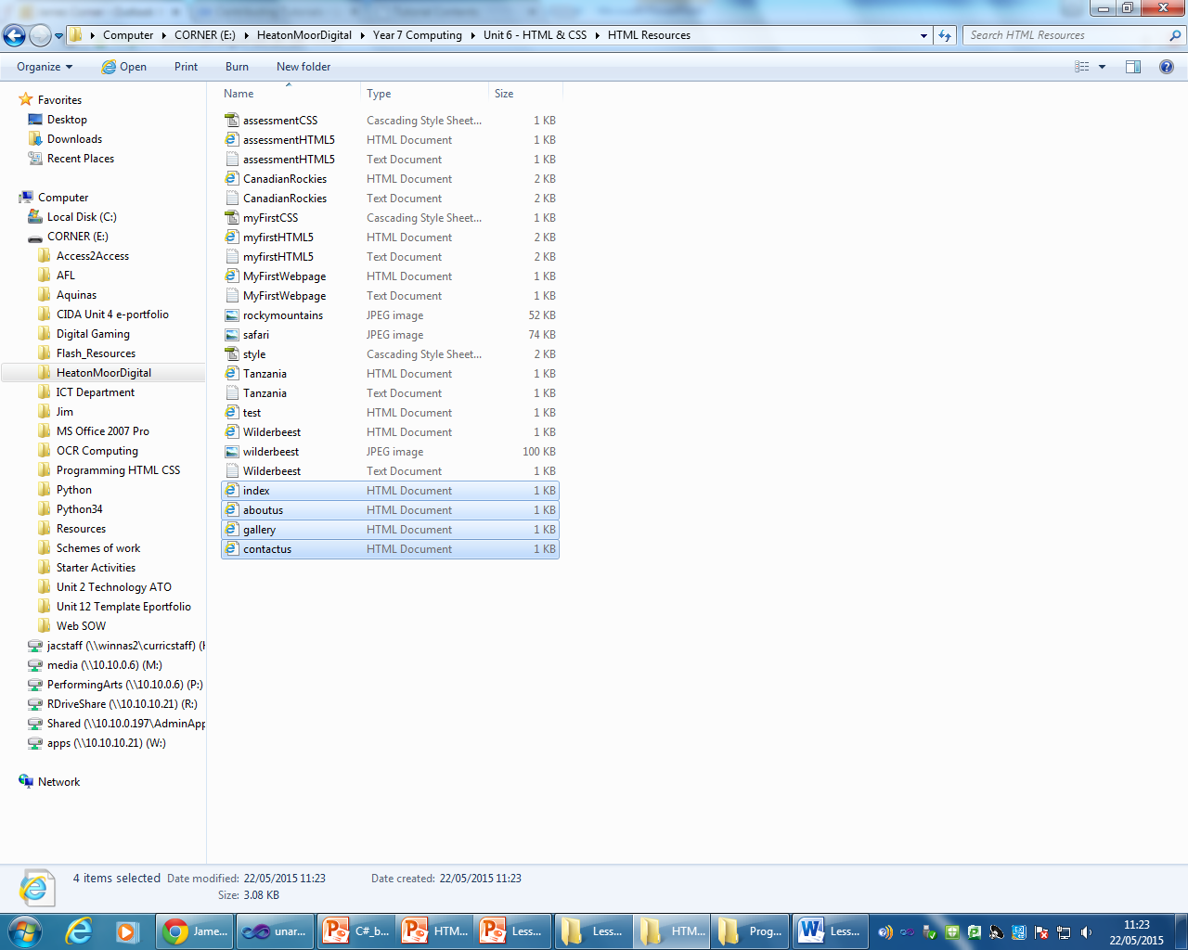**Task 6 – Saving the Other Pages**

Now click File 🡪 Save as again to save and create your other pages

If you have a Hyperlink **“AboutUS”** save the page as **AboutUS.html**

If you have a Hyperlink **“Gallery”** save the page as **Gallery.html**

**Task 7 – Saving the Other Pages**

Open each of the other pages and create content for each page and save. Preview each page in a Web Browser.

**Task 8 – Testing and Improvements**

Open your website in a Web Browser and check that it is set out correctly, that the spelling and grammar is all correct and that the hyperlinks all work. Amend the HTML and CSS to rectify any mistakes.